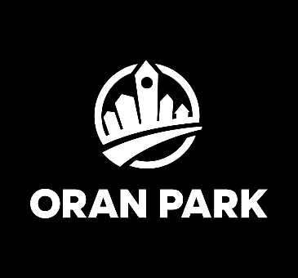
Background to the Oran Park
Town Centre Planning Proposal
The Oran Park Town Centre was originally planned in 2007
and Greenfields has been working to deliver that vision since then.
However, several major developments have influenced how the
Town Centre is expected to evolve. These include:
- The NSW Government’s decision to reserve land for a future extension of the Metro rail line from Bradfield to Macarthur
- The identification of land within the Town Centre for a future station and associated construction compounds and
- The announcement of the Western Sydney International Airport, which is opening for freight in July this year and for passenger flights in October 2026.
These changes, together with some minor updates to building regulations, have led Greenfields to ask Council to change certain planning controls applying to the Town Centre. Council is currently undertaking initial consultation with landowners around the Town Centre about these proposed changes, with submissions closing this Monday, 16 March 2026.
The key changes relate to the footprint of the Town Centre and building heights at a limited number of locations. These proposed changes have been shown on Greenfields’ Oran Park Masterplan for more than five years. The area affected by these changes is edged red below.
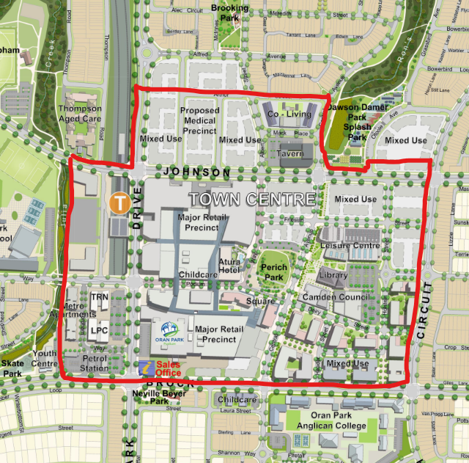
The main proposed changes to the existing planning controls
Expansion of the Town Centre
What is proposed?
The Town Centre will expand to the north, rezoning land currently zoned R3 Residential to B2 Local Centre. The expansion area is north of Dick Johnson Drive.
Why is it proposed?
The expansion of the B2 zone will in part compensate for areas of the existing B2 zoned land in the Town Centre that already have been, or will be, used for uses not initially considered in the planning of the Town Centre. These include the Metro Rail and Station corridor, commuter car parking and the Oran Park Leisure Centre. We are also taking the opportunity to match zone boundaries to existing or future logical road patterns, which were not known in 2007 when the original planning for the Town Centre was done.
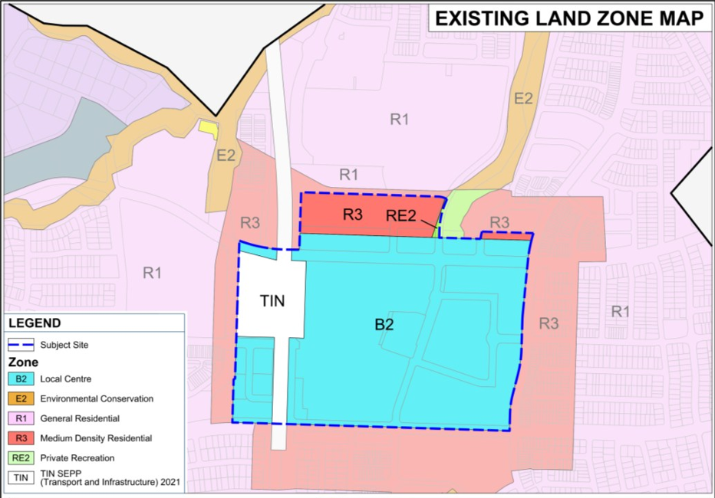 | 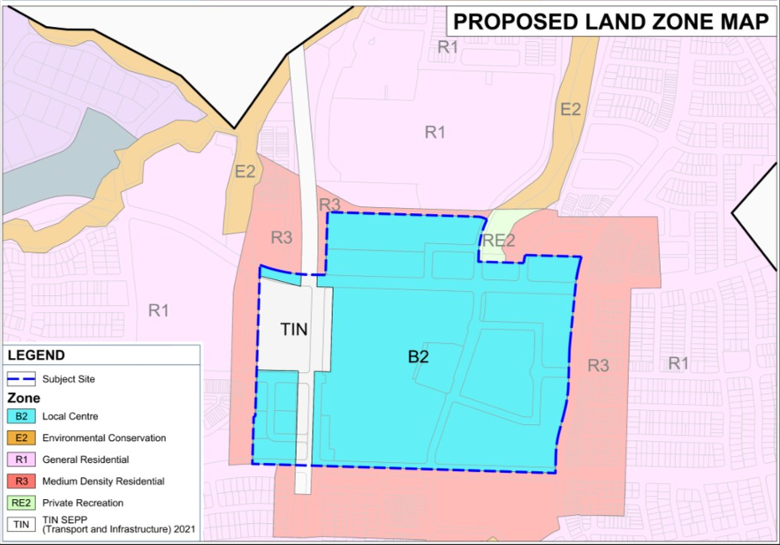

Additional building heights in specific locations
What is proposed
Height controls currently applying to the Town Centre are either 24m or 47m, with the 47m height limit applying to only one site, on the corner of Central Avenue and Podium Way. An apartment development of 13 storeys was approved on this land in 2020.
The planning proposal seeks to permit 48m high buildings on several specifically identified sites in the Town Centre. On land affected by the current 24m height limit, the planning proposal seeks to increase the height limit to 25m.
Why is it proposed
The planning proposal responds to Government policies to increase densities around transport nodes. The areas of proposed height changes to 48m will be limited to specific sites of the Town Centre, creating opportunities for prominent corner and corridor buildings to frame the Town Centre’s streets. Generally, 13 storey apartment buildings and 12 storey office buildings would be allowed at this height.
The locations where the additional height up to 48m is being sought are generally towards the middle of the Town Centre, where they will have minimal impact on existing homes outside the Town Centre and where public open spaces will not be overshadowed.
The increase from 24m to 25m for the balance of the B2 Zone is proposed in response to Building Code of Australia amendments which have increased internal floor to ceiling heights for commercial buildings. Generally, buildings up to 6 or 7 storeys would be allowed at this height limit, depending on the mix between commercial and residential uses within the building. The Metro Apartments and TRN House are examples of buildings that have been built at this height limit.
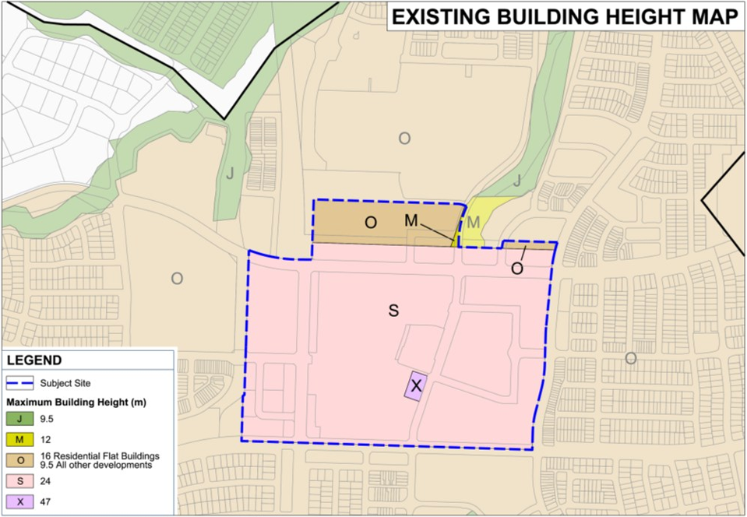 | 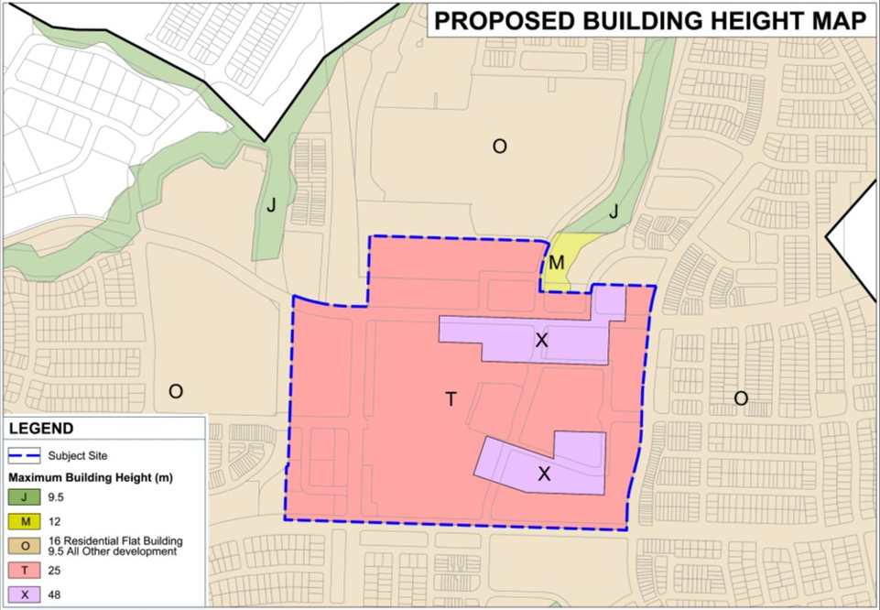

Q. What type of development can I expect?
A. Buildings like the Metro Apartments and TRN House are at the scale permitted by the proposed 25m maximum height. A 13 storey apartment building was approved in 2020 on the corner of Central Avenue and Podium Way (opposite the Atura Hotel). That is the maximum number of storeys which could be achieved under the proposed 48m height limit.
A representation of the likely land uses and the maximum building heights allowed under the planning proposal is shown below. This is a representation only, and land uses may not exactly align with what is shown below because of the flexible, mixed use nature of the Town Centre’s zoning. Any new buildings would require development applications to be lodged with Council for assessment
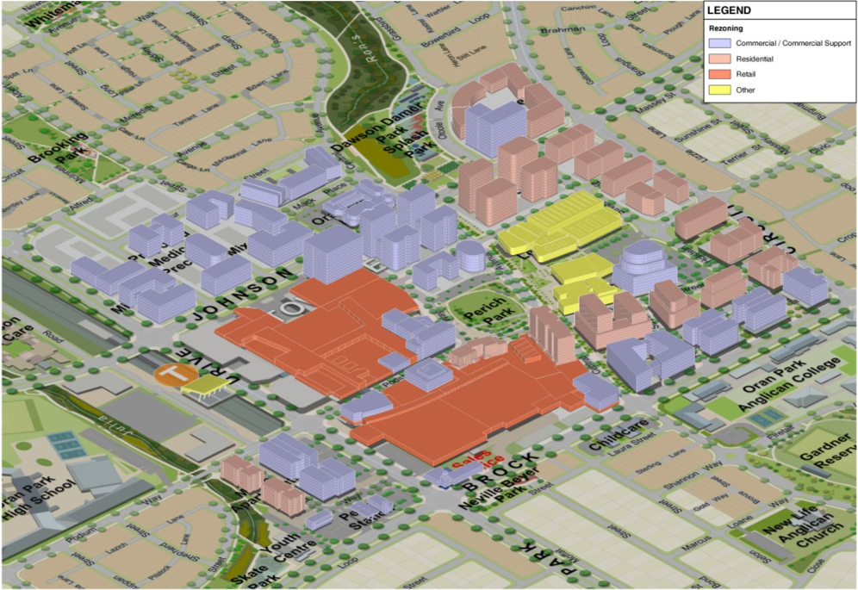

Q. Will the existing infrastructure cope with this additional development?
A. Yes. The planning proposal documentation includes reports by specialists who have assessed the capacity of water, wastewater, electricity services in and around Oran Park Town Centre. Some services will require upgrades, which Greenfields is required to do at its expense. Upgrades to water infrastructure have already commenced.
The recently completed Oran Park Leisure Centre is larger than originally proposed and includes bigger and better facilities. These improvements to the Leisure Centre anticipated the additional demand for recreation uses brought about by this planning proposal. Existing roads and intersections in Oran Park Town Centre have been designed to be augmented for additional traffic, if necessary.

Q. How do I make a submission?
A. You can share your thoughts on the Planning Proposal package by making a submission to Council. Submissions should be received by Monday, 16 March 2026 and can be:
- completed on-line at www.yourvoice.camden.nsw.gov.au
- e-mailed to mail@camden.nsw.gov.au
- posted to Council, addressed to Camden Council, PO Box 183, CAMDEN, NSW, 2570
Submissions should:
- be addressed to the General Manager (Attention: Nicole Aiken – Senior Strategic Planner) and quote Reference PP/2021/6/1
- include the name and address of the person or organisation/company making the submission
- provide a contact telephone number and e-mail address (where available)
- Set out your views on the Planning Proposal package. Please specify the relevant document title and page numbers within your submission as appropriate.
Submissions should be sent to Council, not Greenfields, but if you have any questions regarding this proposal, please contact the Oran Park Sales Office on 90043 7500 or salesoffice@greenfields.net.au

